Wireframe Documentation

**Deloitte Case Study**

**Homepage**



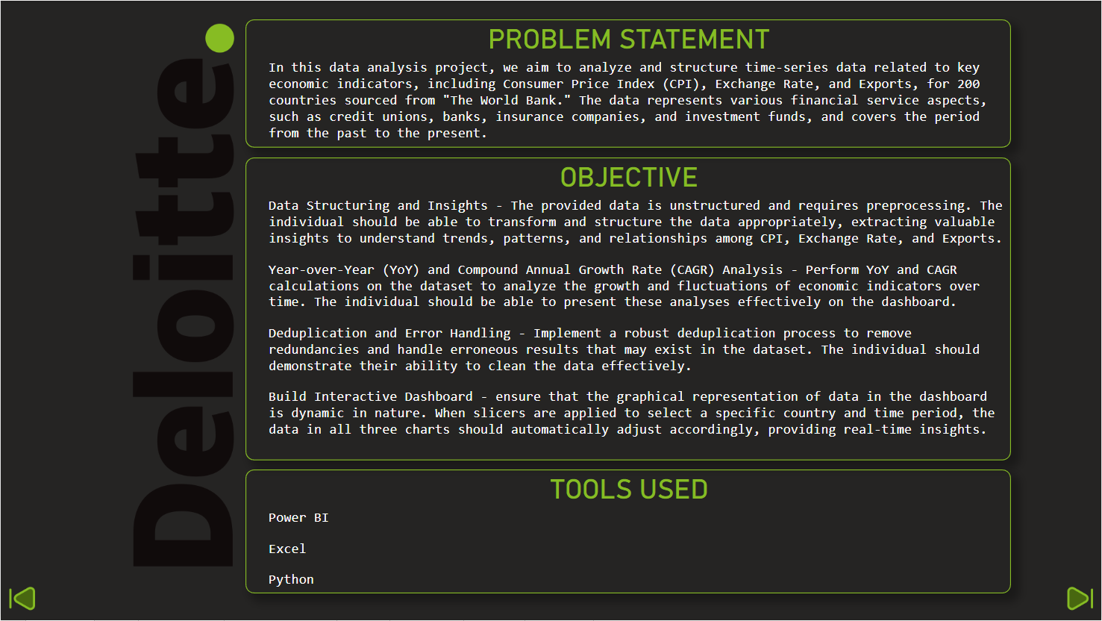

This is our overview

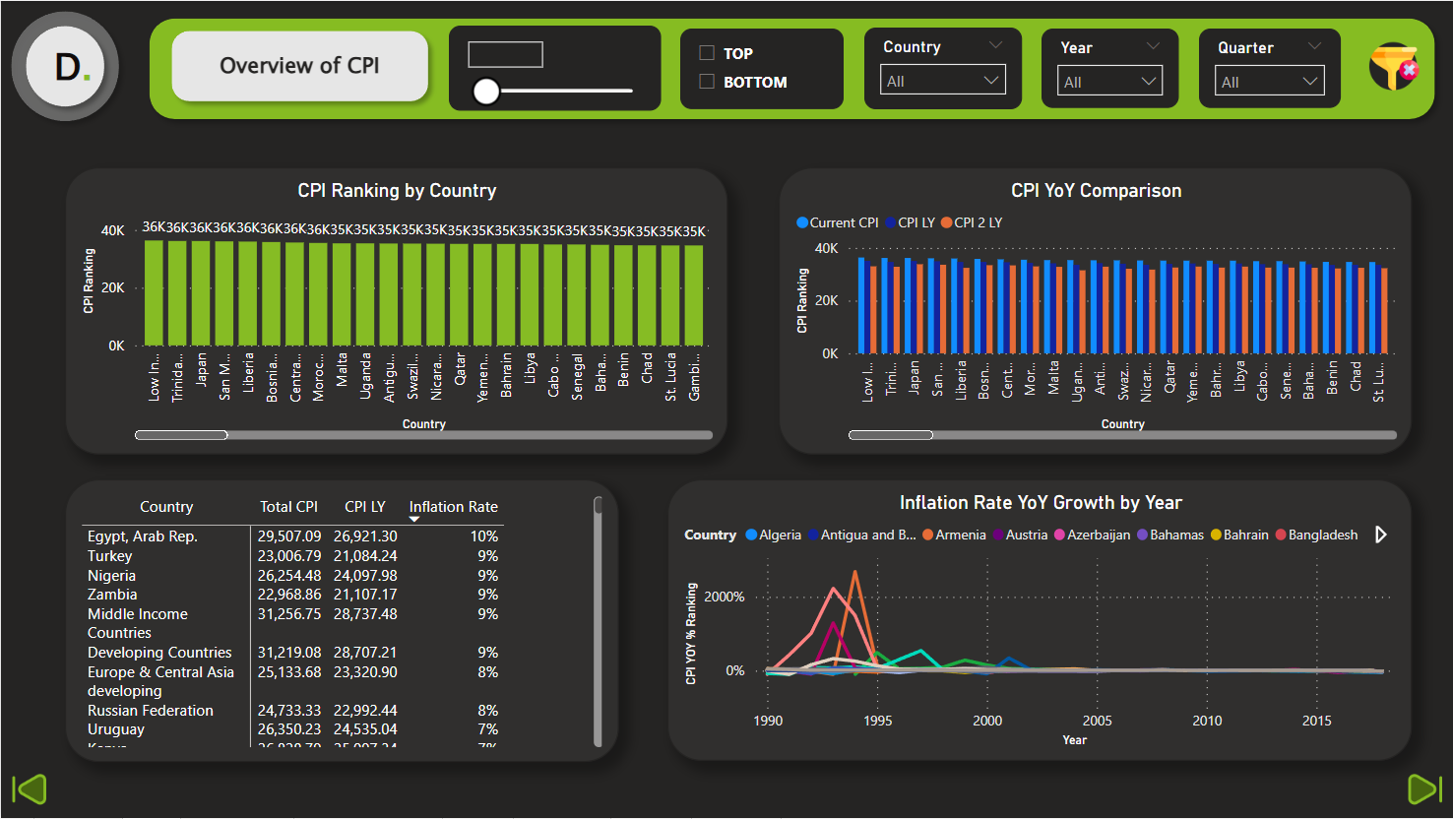

This is the cpi of every country from the year 1991 to 2017

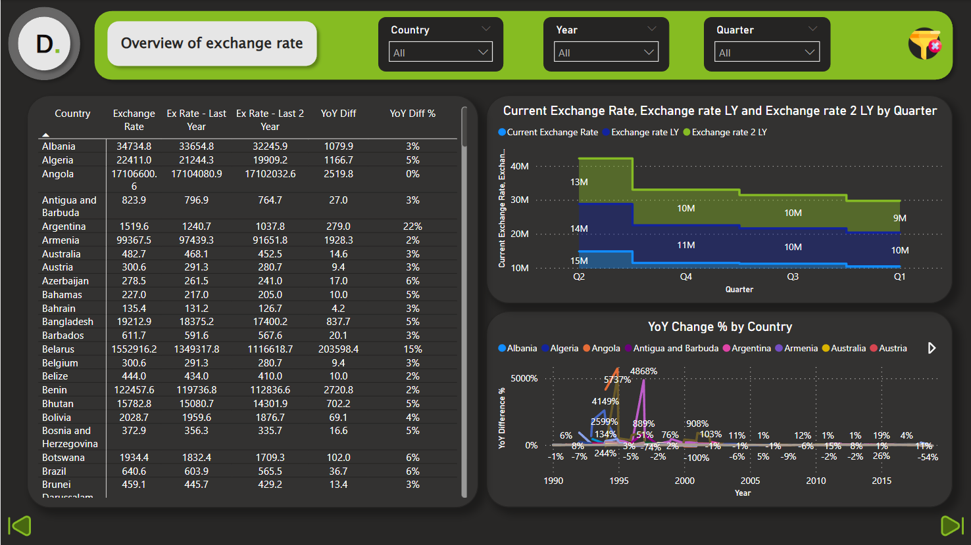

This is the Exchange Rate of every country from the year 1991 to 2017

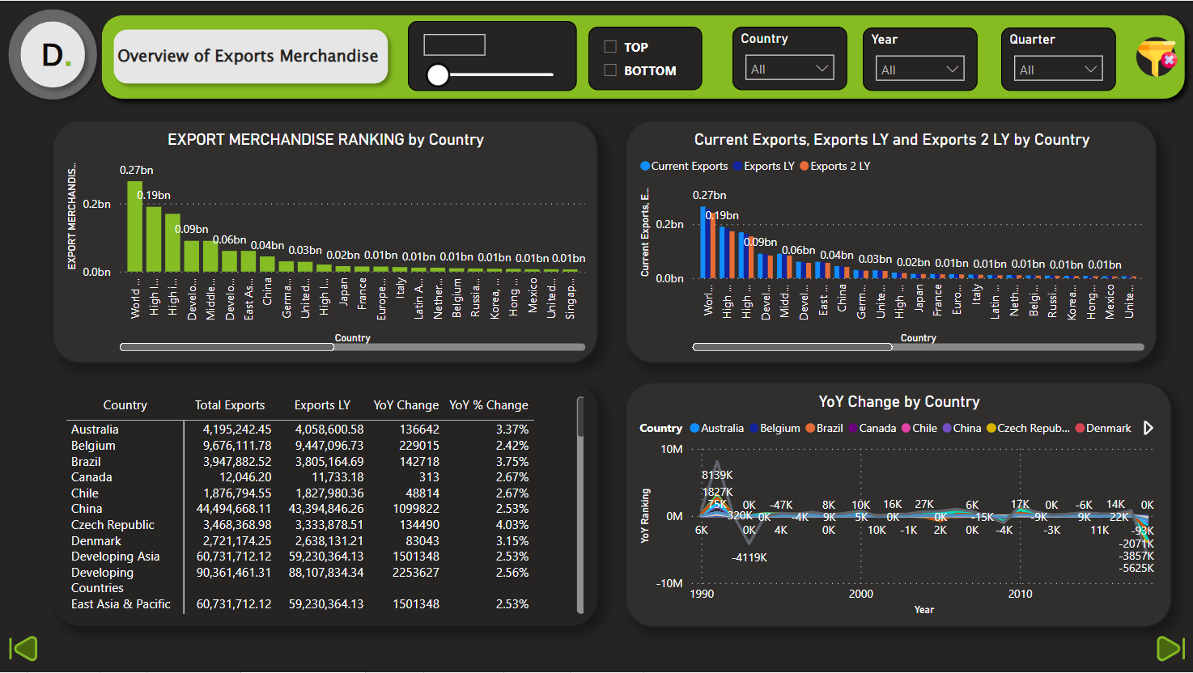

This is the Export Merchandise of every country from the year 1991 to 2017

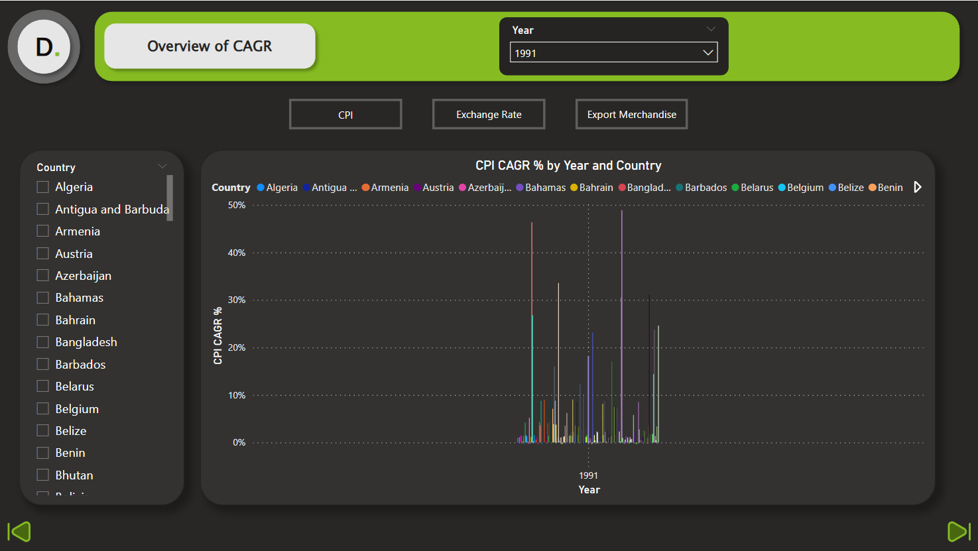

This is the CAGR of every country from the year 1991 to 2017

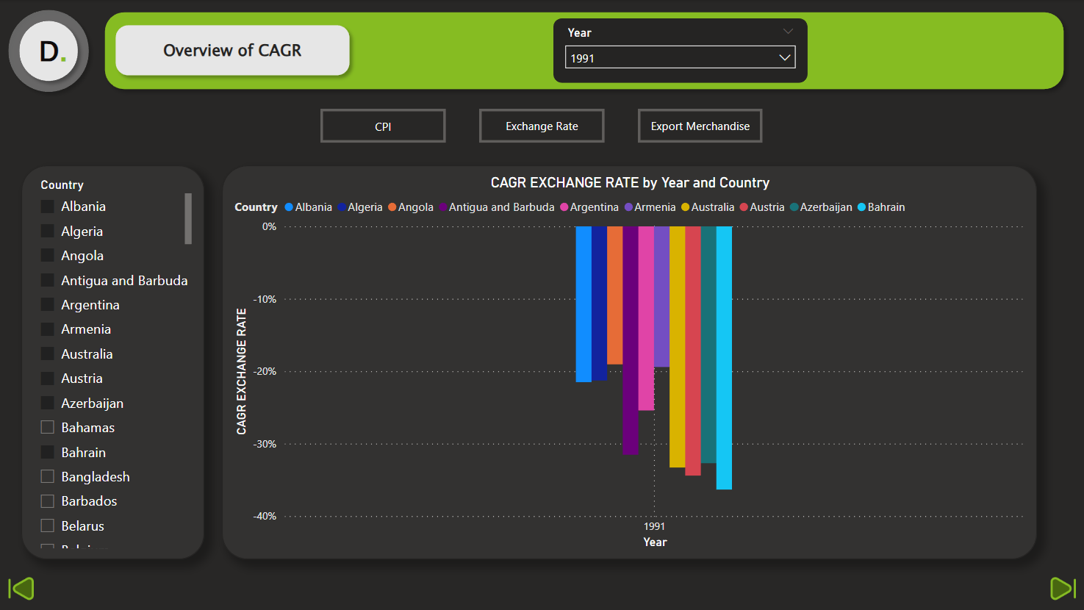

This is the CAGR exchange rate of every country

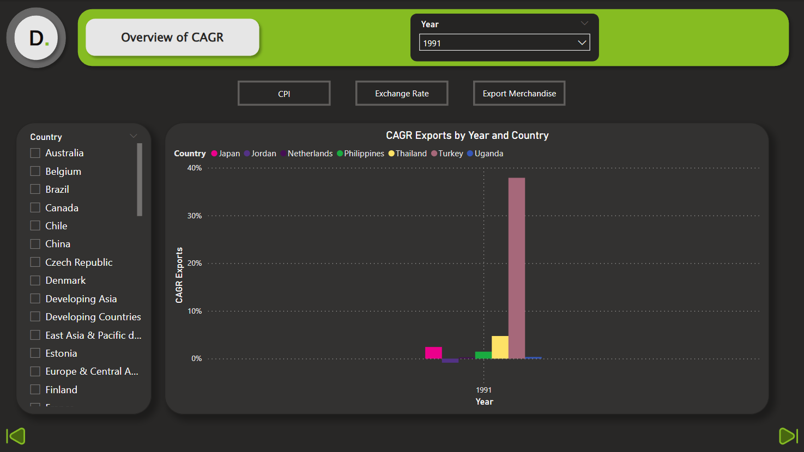

This is the CAGR exports of every country.

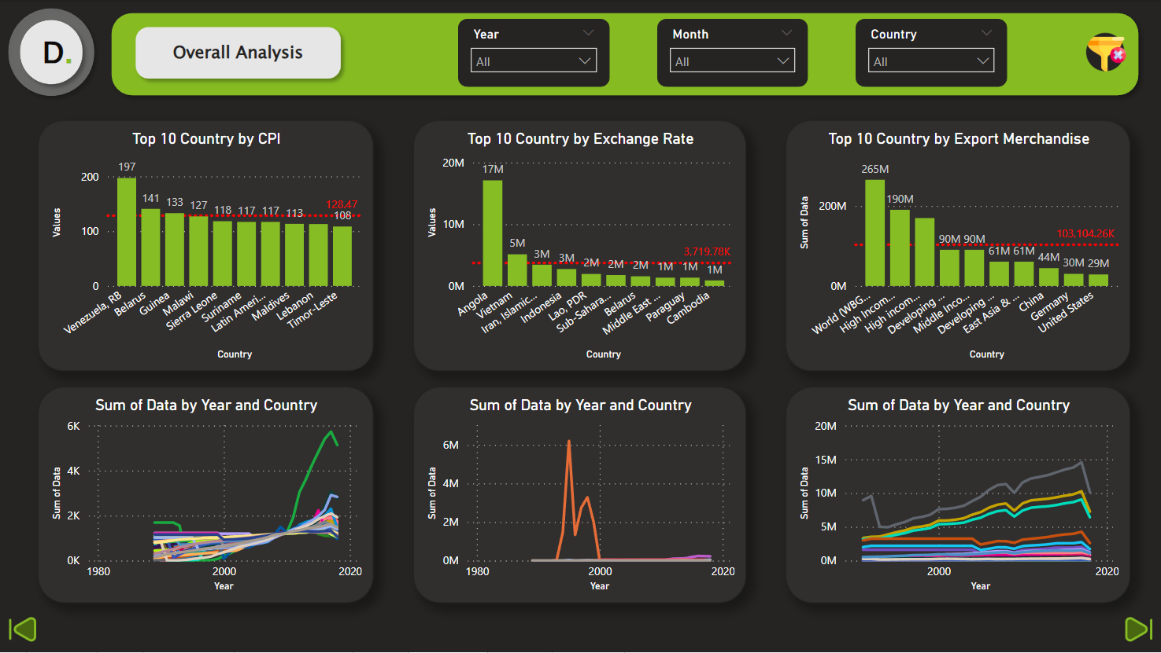

This is the Exchange rate of every country from the year 1991 to 2017

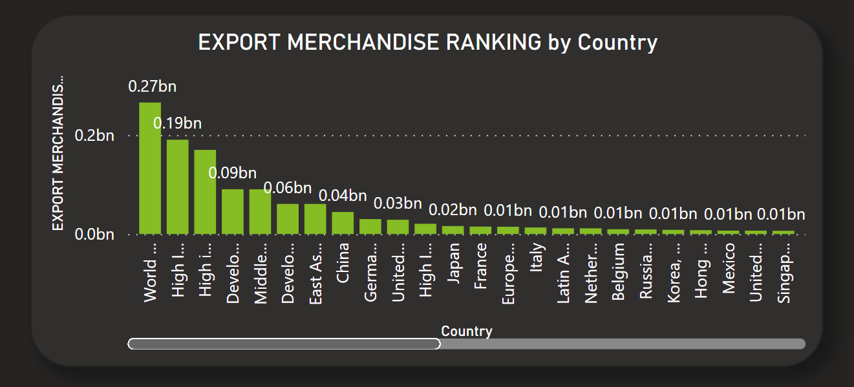

This is the Exports of every country

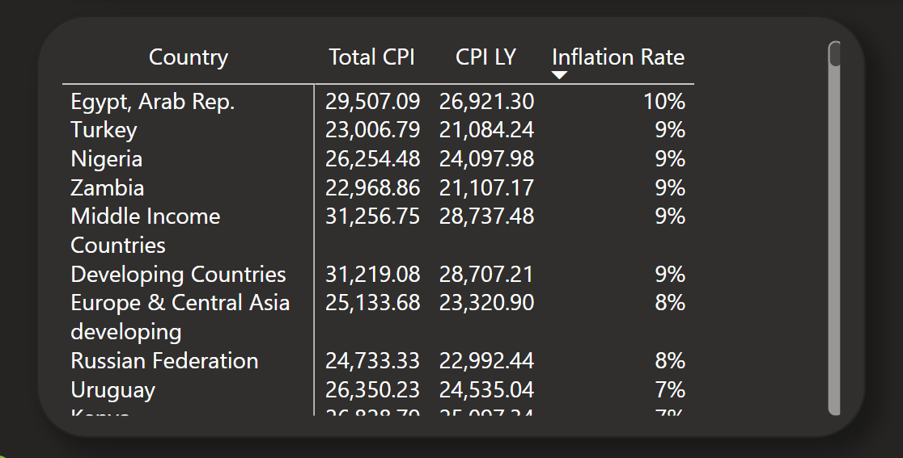

This is the YoY of CPI which explains us about INFLATION

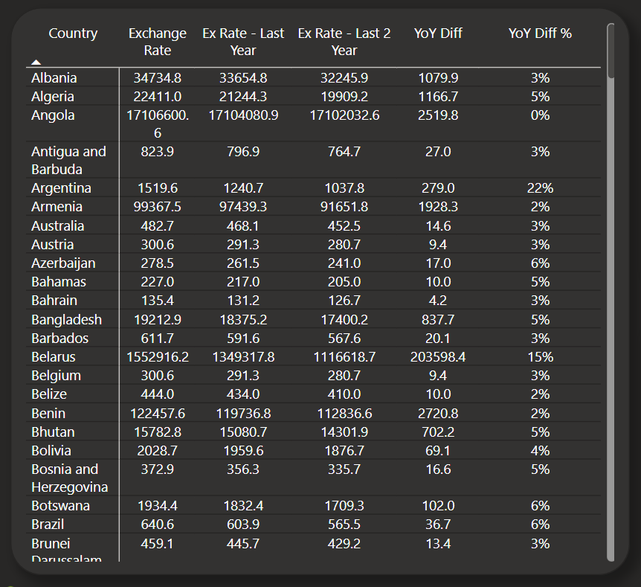

This is the YoY of Exchange Rate which explains us about INFLATION.

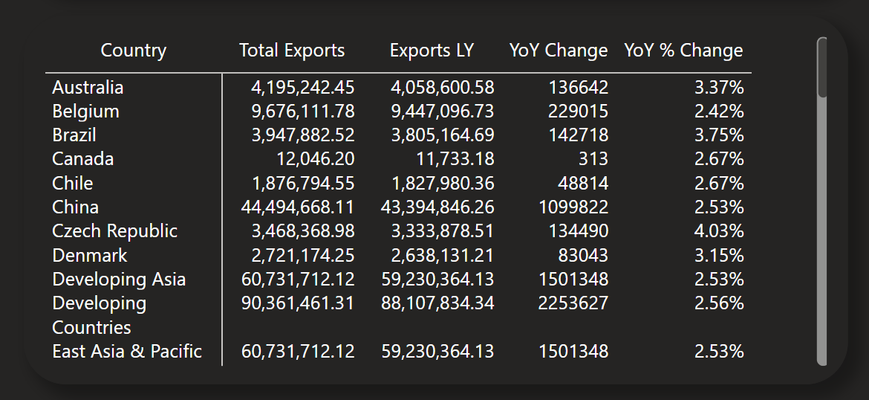

This is the YoY of Exports which explains us about INFLATION